教育部補助博士班研究生出席國際會議報告
研發處補助序號：101J0033E1
姓 名 | 劉家興 | 會議期間 | 2012/09/16~2012/09/20
會議名稱 | 中文：第38屆微奈米工程國際研討會
會議名稱 | 英文：38th International Conference on Micro and Nano Engineering(MNE 2012)
受補助項目  (敬請依核定申請表填寫) | 機票費：__38,000___註冊費：___0____ 生活費：___0____ 合計總金額：__38,000__
出國報告  (至少兩頁以上) | 此次MNE2012會議包含五個相關研討會，約800篇論文發表，本人參與的會議是38th International Conference on Micro and Nano Engineering (MNE2012)．今年MNE開會的時間是從9月16日至9月20日，共計5天，地點是在法國土魯斯．前來MNE與會的皆為專精於奈米壓印技術的國際學者，將結構應用在不同領域上的應用分享，並且在會議中邀請多位專業學者參與分享經驗與成果，彼此共同討論與交流．而我在會議中發表研究成果與各國學者分享研究心得．會議中，舉辦的多場演講，也請了多位大師來分享研究心得，我主要是研究捲對卷奈米壓印應用於抗反射結構上，有效提升穿透率，達到高穿透的微結構；會議中有兩位日本學生也是做相關的研究，探討不同光阻材料做分析，而利用捲對卷製程方面作深入研究．  此次藉由國科會補助經費前來參加MNE 2012在法國土魯斯所舉辦的微奈米壓印會議，深深的感謝研發處能夠補助我此項出席費用，降低我煩惱出差經的負擔，並且讓我能夠充分地學習各國學者與分享學術心得，回國後對於研究領域能有更進一步的啟發，收穫良多．在和幾位學者討論相關研究領域的東西，從彼此談話中可以學習到對方所想要研究的領域，與奈米壓印領域中仍然有許多需要投入研究發展的區塊，帶領我具有更深入的國際觀，使得我能夠在日後研究上，更加深入地去探討問題並擴展問題未來可能發展的方向，吸收對方的意見以及他們不同的想法，互相切磋學習，彌補以往所沒關注到的研究細節．對於我在後續要研究奈米壓印的領域有莫大的幫助．  會場中,有許多廠商來贊助並提供資訊,日本廠商綜研化學株式會社對於抗反射模具得提供與捲對捲的資訊提供有莫大的幫助,提供了蛾眼結構,柱狀結構,孔狀結構,等多種結構模具,尺度皆在200奈米以上,在模具的製作上無非是一個很大的幫助,讓我著實在這塊領域中,又多認識了一間對我有幫助的廠商.  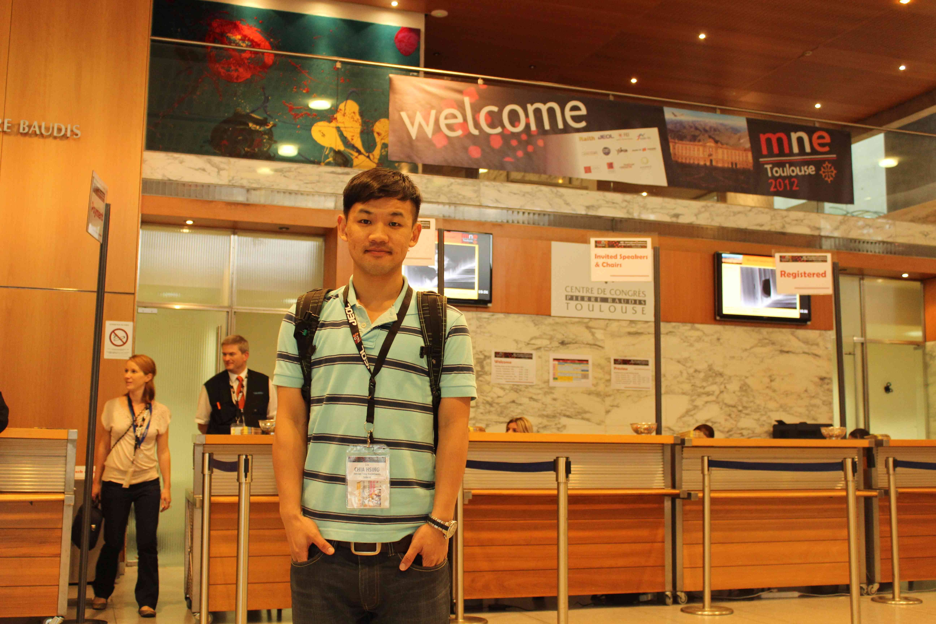
發表論文  全文或摘要  (請勿以附件方式給予) | This study developed a fabrication process of the large-area anti-reflection nanostructure on a polyethylene terephthalate (PET) substrate with Ni-Co template and replicated by roll-to-roll (reel-to-reel, R2R) [1] process. Figure 1 shows the schematic plot of the R2R nanoimprint system with offset gravure coater, in which a rubber-covered offset roll is added between gravure and steel back-up rolls. The UV resin (PAK-02), as the coating compound, is ﬁrst transferred onto the offset roll and then onto the PET substrate. For attaining maximum filling ratio and thin residual layer, sufficient UV resin was fed by controlling the velocity of the three rolls and then the excess UV resin on the gravure roll was scraped off. Herein, the UV resin (PAK-02) with low viscosity was chosen in order to obtain faithful replication of nanostructures and the least thickness of residual layer with low imprint pressure. In the R2R process, tension rolls control the parallelism of substrate by the adjustment of force uniformity, while the back-up roller applies normal force on the PET substrate to improve the filling ratio. This technique not only provides high-efficiency nanoimprint process capability, but also implies potentials for low-cost, environmentally friendly, and high-yield properties of R2R-nanoimprint lithography.  Conventional nanoimprint lithography (NIL) [2] requires a flat imprint surface for pattern integrity, control of temperature and pressure uniformity [3], and demolding tricks. This work reveals the achievement of a large-area anti-reflection layer by roller-nanoimprint lithography fabricated directly on PET substrates. Figure 2 illustrates atomic force microscopy (AFM) images of the cross-sectional view of the mold mounted on the R2R system, which is made with 5×5cm² on Ni-Co template by laser interference lithography with diameter, pitch, and height of 300 nm, 300 nm, and 130 nm, respectively. In the roller nanoimprint lithography, the original thickness and uniformity of the resin influences the filling ratio of cavities. As shown in Figure 3(a), the moth-eye nanostructure was fabricated by R2R process on the PET substrate. Figures 3(b), (c) and (d) illustrate the surface roughness of moth-eye nanostructures of various areas. On the different locations, the UV resin fills the cavities on the PET substrate. It is obvious that the surface roughness of moth-eye nanostructures is better than previous work [4]. Figure 3(e) implies that the UV resin could not fill the cavities at different locations of the same sample. It may attribute to that the thin initial resin thickness may result in low filling height of the cavity. The proposed method integrates an offset gravure coater module into a R2R system to introduce the advantages of high-efficiency, low-cost, positioning-possible, and environmentally-friendly. Although it provides less residual layer, a residual layer-free structure is expected for further process requirements. The fabricated polymer films would have great potential to be applied to consumer optical products when anti-reflection/anti-glaring is mandatory.  Spectrophotometer and a contact-angle measuring device have been used to investigate the properties of moth-eye nanostructures. Figure 4 shows the transmittance and reflectivity of different locations of the sample of Figure 3(a). Results show that the moth-eye nanostructures can increase the transmittance by 3% and reduce reflectivity by 4% compared with samples without moth-eye structures in visible region. In addition, the contact angle with water on the moth-eye nanostructures increases by 20 degrees compared with the non-structured PET substrate.

※受補助之學生請於回國後將此表填妥後上傳至校務資訊系統，並點選開放報告後，始得辦理後續核銷作業。

